The Rhetoric of Glacial Melting: Scientific Literature versus Popular Science
While scientists, citizens, and politicians may not have reached a shared consensus about the causes and consequences of glacial melting, there is no denying that it is occurring, and doing so more rapidly than in previous years. The glaciers of Greenland have been a key interest among scientists for many decades, as Greenland contains the second largest body of ice on the entire planet, only following the Antarctic ice sheet (“Britannica”). Greenland Melting (360⁰) is a video published by Frontline, a television program on the Public Broadcasting Service (PBS) network. This popular science exhibit follows the work of Eric Rignot, a professor at the University of California and NASA scientist, and is an adaptation to a scientific article, “Spreading of warm ocean waters around Greenland as a possible cause for glacier acceleration”, written by Rignot and three fellow scientists: Fenty, Menemenlis, and Xu.
As scientific studies are converted to popular science articles, videos, or websites, the authors must “bridge the enormous gap between the public’s right to know and the public’s ability to understand” (Fahnestock 276). Popular science exhibits are often created to show the potential value a study’s results can have on society, but it is the responsibility of the author to adapt and simplify the information without misrepresenting or changing the original findings. Popular science sources can be inaccurate and unreliable, but they can also be extremely helpful, eliminate confusion, and greatly expand the target audience (Fahnestock 276). The PBS video and corresponding scientific article appeal to different audiences as they explain the same material by focusing on distinct points and employing vastly different levels of language and vocabulary. The rhetorical appeals, language, and structure distinguish the video from the scientific paper, and display a shift in genre and audience appeal as Greenland Melting (360⁰) explains the cause(s) of glacial melting in a manner that will be understood by all Americans and ultimately persuade them of the reality and serious consequences this phenomenon will cause.
Shifts in Genre and Rhetorical Appeals
In Accommodating Science, rhetorician and English professor, Jeanne Fahnestock, walks readers through the accommodations, changes, and sometimes complete transformations that pieces of scientific literature undergo when they are adapted into the world of popular science. A key point of the article is the idea of shifting genres, or changing rhetorical focus and techniques (Fahnestock 278). The three overarching categories of rhetoric used today were outlined by Aristotle, an ancient Greek scientist and philosopher, in the 4th century B.C. These are deliberative, epideictic, and forensic/judicial rhetoric (Fahnestock 278). While these initial definitions and descriptions were mostly created for and used in the legal system, rhetoric is now employed and analyzed in all genres involving verbal or written communication. The three rhetorical branches can most simply be organized according to time (past, present, and future), although each also carries with it a unique purpose and situation. Forensic rhetoric is the form concerned with the causes of past events, which correlates with research and investigation in the field of science. A more subjective approach, epideictic rhetoric, involves current judgment and value decisions on whether something deserves “praise” or “blame”. Finally, deliberative rhetoric refers to future events and ideas by advocating for or against particular actions (“The Forest of Rhetoric”).
As a peer-reviewed scholarly article, Rignot’s paper posted in Annals of Glaciology maintains a formal tone ingrained in forensic rhetoric. The article utilizes forensic rhetoric as it describes the research and analysis of past and present data while intending to discover the cause(s) of these melting glaciers and inform readers of the findings. The research and conclusions are recorded as purely factual statements that are able to imply the greater environmental importance on their own, as seen in the first sentence: “Greenland glaciers have been experiencing a growing mass deficit in the last two decades, half of which is caused by an increase in surface melt and half by an acceleration in glacier flow” (Rignot et al. 257). While the statement makes no direct claim about the matter, common knowledge allows readers to understand that glacial melting is a serious environmental issue, and thus the study is relevant and useful to modern science. This is consistent with Fahnestock’s statement, “Scientific papers are, for the most part, explicitly devoted only to arguing for the occurrence of a past fact; significance is largely understood” (278).
Similar to the scientific article, the popular science video by Frontline also relies on forensic rhetoric. It was created with the primary intention of educating, but also combines with epideictic rhetoric to verbally and visually represent the environmental significance of the study. Under epideictic rhetoric, the deontological appeal is used, which “attempts to praise or excoriate something by attaching it to a category that has a recognized value for an audience” (Fahnestock 279). This approach, also described as an appeal to wonder, is riddled throughout as the video investigates an already widely-known and important topic, glacial melting. As the scientists explain the technology and machinery used during the journey, leading NASA scientist, Josh Willis, describes the probe and radar technology saying, “[it radios] data back from the surface all the way to the sea floor, something we’ve never been able to do before” (“PBS”). By emphasizing the novelty of this technology, the video appeals to wonder and persuades the audience that because the project is developing new scientific methods and findings, the research must be significant. A second appeal to wonder focuses on the opinions and reactions of the scientists, and less on the data. Rignot says, “The changes that we are witnessing are amazing. None of us expected to see such changes in Greenland” (“PBS”). Again, this idea of “new results” appeals to epideictic wonder, as the scientists express awe about their original discoveries.
Out of context, Rignot’s use of “awesome”, the idea of significant scientific findings, and the term “wonder” used as the appeal all imply a positive condition. However, the PBS video appeals to wonder with a fearful and melancholy shadow. In referencing the Greenland ice sheet, the narrator says, “If it all melted, it’s estimated that the sea level around the world would rise by about 20 feet” (“PBS”). The results do not elaborate on the future benefits or possibilities of research, nor do they propose a possible solution to prevent glacial melting. Instead, the video focuses on the decades of ongoing research and how the study has yielded original data regarding the reality and probable cause of glacial melting. To conclude the video, Rignot uses a combination of epideictic and deliberative rhetoric as he tells an emotional, yet hypothetical story. Rignot says, “My kids and grandkids are going to look at me and say ‘You knew this was happening. What have you done to slow it down?’ I studied them [glaciers] and I reported the results to people. I’m not sure that it was enough, but I did the best that I could” (“PBS”). Rignot’s statement references the future and evokes an emotional response from the audience, neither of which occur in the scientific literature. The use of all three rhetorical branches in the popular science video demonstrates how the scope of the exhibit is shifted from the paper to the video. While the paper is purely focused on empirical evidence, the video seeks to provide viewers with accurate data while simultaneously exemplifying the significance of the study and the future implications these findings will have on our planet.
Language and Audience Appeal
While the rhetorical figures change between exhibits to emphasize relevance versus data, the language also shifts to appeal to different audiences. The syntax and general linguistic composition of scientific writing, and communication in general, have an immense effect on the audience appeal, or which people/groups are interested in the work. The audience for the scientific paper is global, but only understood by those with a scientific background in the field. This is clear by the vocabulary use and general focus of each section. Rignot and the authors of the article utilize field-specific and scholarly diction in every sentence. For example, the phrase “due to an increase in lateral ocean heat flux convergence and a decrease in air– sea heat loss” (Rignotet al. 257) and the word “parameterization” (Rignot et al. 258) are unlikely to be understood by a general audience. Because the article must present the most accurate and specific information of the study, the authors are not concerned with describing the data in common language or clearly explaining the implications of the results. The greatest focus of the article is that of temperature data analyses regarding scientific models. The paper mentions “model” over 80 times and concludes with, “Our results suggest that high-resolution ocean models will soon become a useful tool of analysis for the glaciological community to address this issue in a quantitative fashion” (Rignot et al. 265). This signifies how the authors created and evaluated their data and again reiterates that only experienced scientists will understand the research.
Contrary to its counterpart, The PBS video is geared toward anyone with a concern for Greenland and or interest in the environmental well-being of the earth. While a video published online can be viewed around the world, the primary intended audience is likely the American public. This is demonstrated by the use of the imperial or “standard” unit system to describe data and measurements, even though the associated article and nearly every country outside of the United States uses the metric system (“PBS”). In addition, PBS, an American broadcasting service, is the distributor and producer of the video, meaning Americans will likely have primary access to the video. To make the information accessible and understandable to the public, the vocabulary is significantly simplified from the article to the popular science video. The scientists and narrator use common language and helpful analogies to explain the complex study. Willis says, “Just imagine an ice cube melting in a glass of water as opposed to an ice cube left out on the counter in the air. The water is really good at melting ice because it contains so much heat, and the warmer the water the faster it melts” (“PBS”). This analogy simplifies the concept of glacial melting, in contrast to the description by the article, which says, “The spreading of warm waters around Greenland must have significantly increased the glacier subaqueous melt rates in the frontal regions” (Rignot et al. 264). Additionally, the video does not mention model configuration or analysis, but instead focuses on giving simple explanations of the technology used and describing how each glacier has changed/deteriorated throughout history. By simplifying the language and shifting the focus, the same data from the original article can now allow a wider audience to understand the process and technology used in the study, as well as appreciate why scientists have been conducting this research for decades. This, in turn, will likely persuade readers that glaciers are undoubtedly melting, that NASA’s research of the subject is significant, and that the probable cause, increased ocean temperatures, should spark further studies and attempts to control this potential catastrophic change in climate.
Structure and Creative Elements
While the language of Rignot’s article was adjusted to create Greenland Melting (360⁰), the structure and visual components of each exhibit were entirely distinct. The scientific literature follows a standard IMRAD (Introduction, Methods, Results, and Discussion) format and includes two data tables and three extensive figures. The structure provides a clear template for the authors to report and analyze all their empirical data, but it leaves little room for an analysis of the significance of the research. In contrast, the Frontline video is a narrative story/educational lesson without a clear structure of information. However, the video composition is quite intricate, involving video footage, photos, videogrammetry, and computer-generated imagery (“PBS”). The video is primarily structured around the most intriguing photo and video collections available. Depicting the cause versus the result of the data is a clear discrepancy between the visuals of the article and those of the video. To clarify, Rignot’s paper is filled with colorful figures showing temperature levels and locations (Figure 1) below the water surface. Meanwhile, the video depicts footage of Greenland’s glaciers, both current and computer-generated images, to display the effects that these rising water temperatures have had on the glaciers (Figure 2). The video published by Frontline has free-range to use creative photos and elements, which allow the audience to visualize concepts versus reading about them. This drastic difference in structure reinforces the article’s strict adherence to fact as well as the video’s epideictic appeal, as the audience is more likely to believe what they see, even if external editing and simulation are used to create the exhibit.
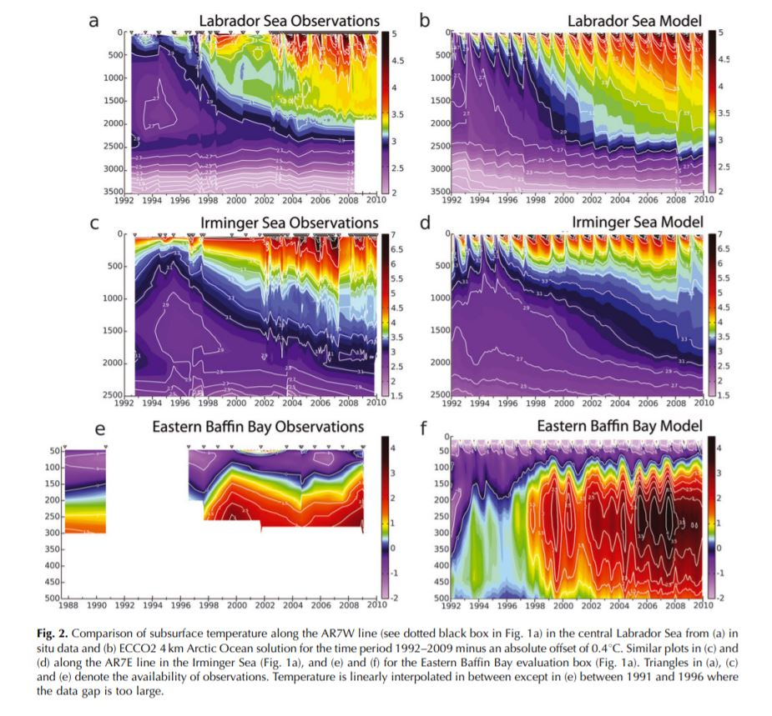
Figure 1: Figure within Rignot's Article - subglacial water temperature chart
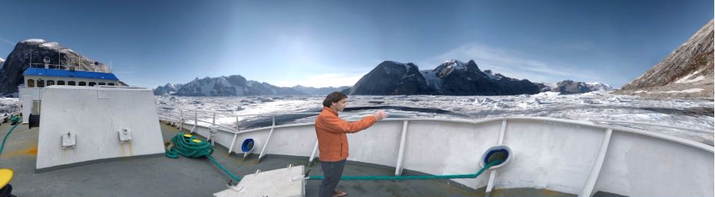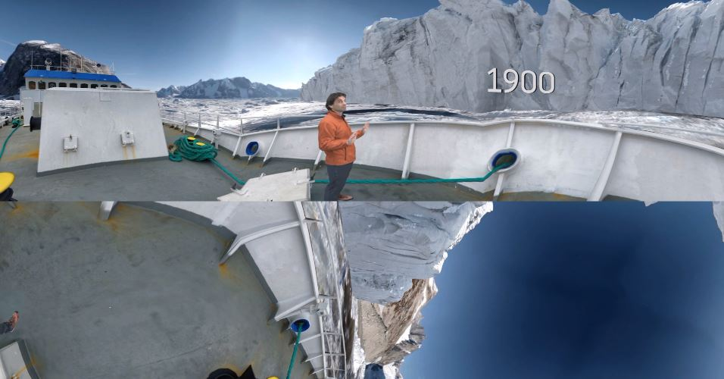
Figure 2: Computer Generated Imagery - Glacier size today (top) and likely size in 1900 (bottom)
The shift from scientific literature to popular science did not alter the conclusions of NASA and Rignot’s study; However, the audience and implications of each were adjusted due to the varying rhetorical appeals, language, and overall composition of the exhibits. Scholarly language, forensic rhetoric, and extensive figures are utilized in Rignot’s paper to convey information to fellow and future scientists. Meanwhile, the PBS video adapts each area of the original study in a way that simplifies the material, conveys it to a much wider audience, and presents both the factual data and interpreted significance of the results. The popular science video situates itself in a larger debate, as Rignot and his colleagues mention climate change and ocean warming as causes of glacial melting. In addition, adapting this study for communication to a general audience is beneficial to those who support the findings because the public is responsible for pollution and political votes – two major factors hindering the improvement of climate change. While Rignot and his colleagues’ conclusions have not been formally accepted as fact, educating the public will create a broader base for supporting future research in the field.

Bibliography
Britannica, The Editors of Encyclopaedia. “Greenland Ice Sheet.” Encyclopædia Britannica, Encyclopædia Britannica, Inc., 16 Apr. 2018, www.britannica.com/place/Greenland-Ice-Sheet.
Fahnestock, Jeanne. “Accommodating Science.” Written Communication, vol. 3, no. 3, 1986, pp. 275–296., doi:10.1177/0741088386003003001.
“The Forest of Rhetoric.” Silva Rhetoricae: The Forest of Rhetoric, rhetoric.byu.edu/.
“PBS.” PBS, Public Broadcasting Service, www.pbs.org/wgbh/frontline/article/greenlands-glaciers-are-melting-faster-than-expected-see-them-in-360.
Rignot, E., et al. “Spreading of Warm Ocean Waters around Greenland as a Possible Cause for Glacier Acceleration.” Annals of Glaciology, vol. 53, no. 60, 2012, pp. 257–266., doi:10.3189/2012aog60a136.

